**All Divisor of a Number**

Given a natural number n, print all distinct divisors of it.

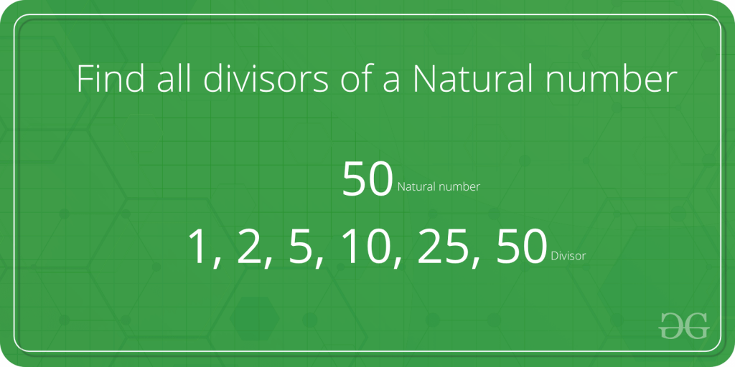

**Examples:**

**Input : n = 10**

**Output: 1 2 5 10**

**Input: n = 100**

**Output: 1 2 4 5 10 20 25 50 100**

**Input: n = 125**

**Output: 1 5 25 125**

C++

#include<iostream>

using namespace std;

int main()

{

int n;

cin >> n;

for(int i = 1; i <= n; i++)

{

if(n%i==0)

{

cout << i << ' ' ;

}

}

return 0;

}

**INPUT :**

**6**

**OUTPUT :**

**1 2 3 6**